Stem Decay (Heart and Butt Rots)
Medium to Low priority
Brown crumbly rot (Fomitopsis pinicola) DDF
Brown stringy trunk rot/Indian paint fungus (Echinodontium tinctorium) DDE
Red ring rot (Phellinus pini) DDP
Schweinitzii butt rot (Phaeolus schweinitzii) DDS

Description
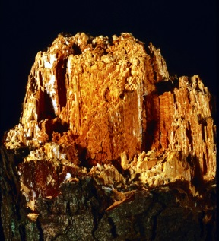
Brown crumbly rot commonly occurs on a wide range of deciduous and coniferous hosts. Coniferous hosts include all true firs, Englemann, white and Sitka spruce, lodgepole, western white and ponderosa pine, Douglas-fir, western redcedar, all hemlocks, and western larch. This fungus is most common on dead trees, stumps or logs, but it can gain entry to living trees through wounds, holes bored by insects or dwarf mistletoe infections. The fungus is commonly associated with wounds, dead tops and dead trees. Brown crumbly rot is one of the most damaging and frequently occurring wound parasites in old-growth forests. The presence of conks indicates extensive decay. Second-growth trees can also be infected, making them subject to breakage and windthrow. The major role of this fungus is degrading and decomposing trees killed by other agents. This role is an important one in the forest for recycling and removing dead woody debris. Both heartwood and sapwood are decayed.

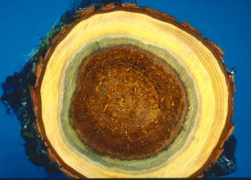
Brown stringy trunk rot: True firs are highly susceptible throughout BC. Hemlock is moderately to severely attacked in specific habitats such as interior forests (usually related to snow damage), high elevation coastal forests and below average sites. Douglas-fir and spruce are occasionally attacked. It may occur on western redcedar. Mature trees with small, suppressed dead branches and stubs are most susceptible. The fungus is not associated with wounds though the initiation of infection may be precipitated by mechanical damage. The conks are reliable indicators of significant decay. The entire cross section of the log is usually decayed 4 - 6 m above and 2 - 4 m below one of these fruiting bodies. Decay may also be present in trees that do not have conks. Heart rot and associated volume losses in mature hemlock and true firs are primarily caused by brown stringy trunk rot.

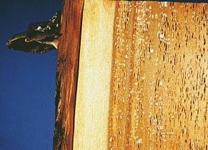
Red ring rot: Western hemlock, pine, spruce, western larch, Douglas-fir and western redcedar are common hosts of this true heart rot decay fungus. Red ring rot has also been reported on the true firs, yellow cedar and mountain hemlock. This fungus attacks living, dead or down trees. Decay by this fungus causes both a loss of volume and a decrease in the grade of milled products. Less commonly, red ring rot can even progress from the heartwood to the sapwood and cause tree death. Losses in B.C. probably exceed the other heart-rots in value due to the broad host range and common occurrence of the fungus. When conks are present the extent of the decay is very large passing several metres beyond that last visible conk. Tree collapse or breakage is common with this fungus.

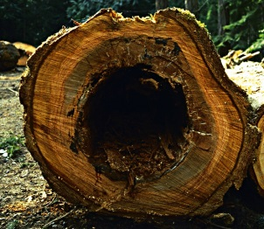
Schweinitzii butt rot: Schweinitzii butt rot is commonly reported on Douglas-fir, ponderosa pine and western hemlock. It has also been found on subalpine and amabilis fir, Sitka and white spruce, western larch, tamarack, lodgepole and western white pine, western redcedar, and Garry oak. This fungus infects mature trees, and is occasionally found on young trees. Schweinitzii butt rot often extends 3m up a tree stem. Since the highest quality and value of a tree is in the basal log, this disease causes serious losses. Rotting of the roots and butt also leaves trees highly susceptible to windthrow and breakage. In BC losses are most severe in Douglas-fir and Sitka spruce.

Extent
Heart rots are a low priority forest health factor in the Bulkley and Cassiar TSAs. Mature and over-mature stands of spruce affected by these rots are often mistaken for stands infected by Tomentosus root disease. There is no known relationship between mature stand infections and subsequent risk to plantations. Heart rots are subject to windthrow events. The losses resulting from brown crumbly butt rot are accounted for in the current decay, waste and breakage factors.
Stem decay fungi are a moderate forest health factor in the Kispiox TSA, due primarily to the abundance of over-mature western hemlock and true firs. A thorough review of the decay, waste and breakage factors for the TSA could have significant implications for timber supply forecasts.

Data

Tactics
- Incidence levels should continue to be monitored and their priority reassessed at the annual review stage.

